Update from OPG on the Power of Attorney wait time position
The Office of the Public Guardian is part of the Scottish Courts and Tribunals Service. We have provided a power of attorney (PoA) registration service since April 2001. Throughout this period, we have been committed to delivering a high level of customer service. However, users familiar with the PoA registration service will be aware of the longstanding backlog and considerably long wait times for PoAs to be processed. We would like to thank users for their patience and understanding during these challenging times. While the wait time position is far from ideal, please be assured that we are taking steps to reduce the backlog and not taking user patience for granted.
Background and context
The backlog and long wait time is largely due to; the impact of the pandemic, the need for a new case management system and a substantial increase in PoA submission rates and in the number of cases requiring maintenance. The volumes of PoAs submitted for registration have increased each year, except during the pandemic year of 2020-21. Last year over 95,000 PoA submissions were received. This is an increase of 30% compared to volumes received in 2016-17. Our business continues to grow with 27,997 PoA submissions received in from July to September 2025. We estimate that over 100,000 submissions will be received this current year (2025-26).
The snapshot below outlines the numbers of PoAs received and processed by the PoA team from July to September 2025.
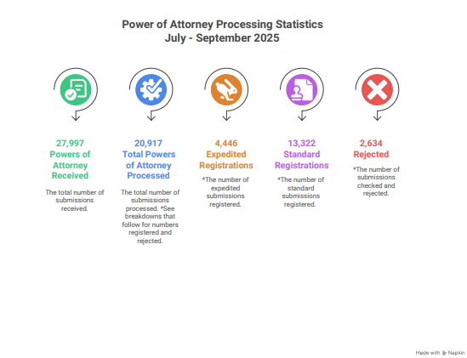

The PoA processing team is based in Hadrian House, Falkirk. The team are industrious and conscientious and are working hard to reduce the backlog.
Those familiar with the PoA position will be aware that the current wait time has now reached over 12 months. We understand and acknowledge that this is not a satisfactory level of service, and every effort is being taken to work on the backlogs. We are continually reviewing processes to work as efficiently possible. To keep users informed of current PoA wait times, information is published weekly on our website, X feed and telephone message.
It is appreciated that in some cases there will be a genuine need for a PoA to be urgently processed due to the granter’s needs and that when there are longer waiting times there is a greater chance of an expedite being sought. For context 1,564 PoAs were expedited in September 2025. Submissions which meet OPG’s criteria for expedited registration are prioritised and processed ahead of standard submissions. The increase in demand for this service inevitably affects the wait time for standard submissions, and we ask customers to use this service only where there is a genuine urgency.
In addition to the increase in volume of PoA submissions, 900K live PoA cases are in the system, of which a substantial number will require maintenance. A similar pattern exists for this work and the number of cases requiring maintenance has steadily increased year by year. In 2024–25 a total of 29,795 cases required maintenance due to changes in the granter or attorney’s circumstances. The snapshot below outlines the position over the last quarter and the number of items worked.
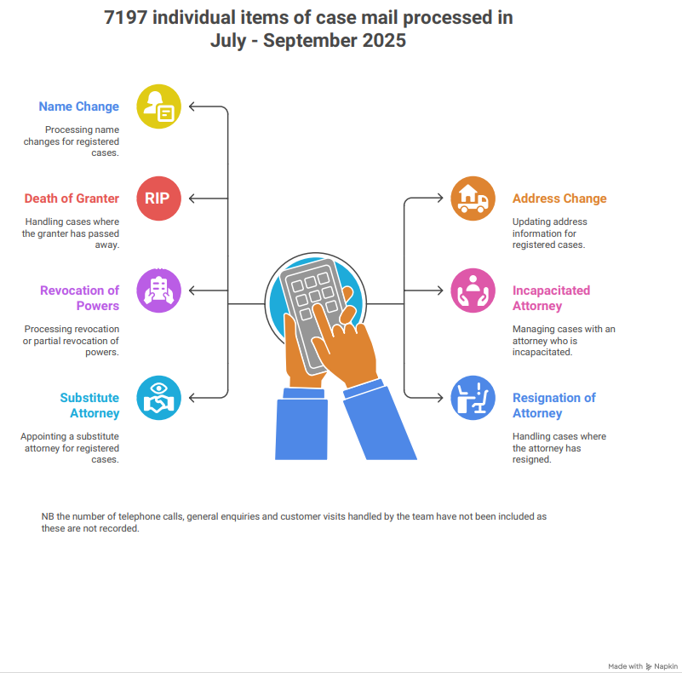

In addition to the substantial increase in volumes of work, our case management system (Sigma), which is 25 years old, has had an impact on waiting times. The system has many issues including an extremely slow processing speed.

Steps taken
We have obtained significant investment from the Scottish Government and the Scottish Courts & Tribunals Service, to replace Sigma. This will be done in three initial phases. The first phase of the new system is in respect of all PoA workstreams. This phase began to go live in January 2025, with a relatively basic but functional version of the new system, PAIGE. As with all projects of this scale, it takes time to train staff, embed a new system, fix bugs and then develop the system further until it is at its optimal functioning state. This work has continued throughout the year. The system, which has been developed on Microsoft Dynamics, will enable PoAs to be processed more efficiently, allow us to start to tackle the backlogs and cope more readily with future demands on the service.
In addition to the above investment, funding was secured in 2025-26 to recruit additional temporary staff to assist in efforts to reduce the backlog. These staff are now fully trained and are focussed on processing PoAs. Staff are also working overtime to aid the recovery efforts where possible.
We wish to reassure users that Scottish Courts and Tribunals Service remain committed to improving and maintaining performance in this area and will continue to take all steps required to deliver a fast, efficient and reliable service.

Expedite service
Users are reminded that where there is an urgent need for a PoA to be processed, that an expedited registration service is available.
The examples below outline the type of urgent situations that meet the criteria of the expedited registration service.
The granter:
- has subsequently lost capacity and urgent decisions need to be made
- has been admitted to hospital and urgent action requires to be taken
- requires to be moved from hospital with a care package or into a care home
- is at risk of financial harm as they cannot act in their own interests to pay bills, care fees etc.
- has been discharged from hospital and a financial assessment is to be undertaken

Upon receipt of an application to expedite a PoA, we will endeavour to process the application within five working days. This expedited registration service is provided where there is an urgent need for a PoA to be processed. We ask that this service is requested where there is a true and genuine urgency as inappropriate use of the service creates avoidable delays for those in most need of the service.

Help OPG help you
From July – September 2025, 2,634 PoAs were returned to the sender as they did not meet registration criteria. Time is spent on all PoAs received as they must be read, checked against the criteria and input in the system. Time was spent on 14% of submissions sent in the quarter and many of these will be resubmitted and require processing, therefore they will be double handled. The top reasons for rejecting a PoA are:
- Names stated on the PoA and on Schedule 1 (certificate of capacity) do not match
- The date of interview on Schedule 1 was omitted or is not the same as the date the granter signed the PoA
- Schedule 1 has not been completed fully at section 5
- No date of birth is provided for the granter (postal submissions)
- Input on EPOAR is incorrect or incomplete i.e. names misspelled or omitted, and details of any substitutes not input
We kindly ask that senders take care to ensure documentation is fully completed, checked and correct before sending for registration.

On the horizon
We have further aspirations to digitally transform our services. This will be possible with the continued investment by SCTS to roll out the new system. Phase 2 of the project will focus on the guardianship, intervention and access to funds functions of the business as well as providing a customer facing, 24/7 accessible Online Public Register. Phase 3 will migrate the functions of the Accountant of Court’s office and both are planned for release throughout 2026/27.
Once Phases 1 – 3 are complete, not only will existing services be more efficient, but we will then have the platform to develop – subject to further funding being available - additional digital functionality for our customers and transform the way in which users interact with OPG by introducing for example, submission portals, “track my application” and verification codes.
Update provided by OPG
End

