How to Register as an Individual on EPOAR

Individual user accounts were designed for Individuals who may only wish to use the system once or a limited number of times.

1. Click on the Register New Individual User option.

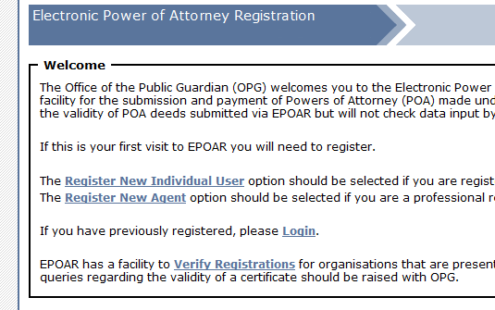

2. Enter Individual User details

Note: the constitution of the password must conform to the following:
Password must be between 6 and 20 characters and contain at least one lowercase character, one uppercase character and one digit.
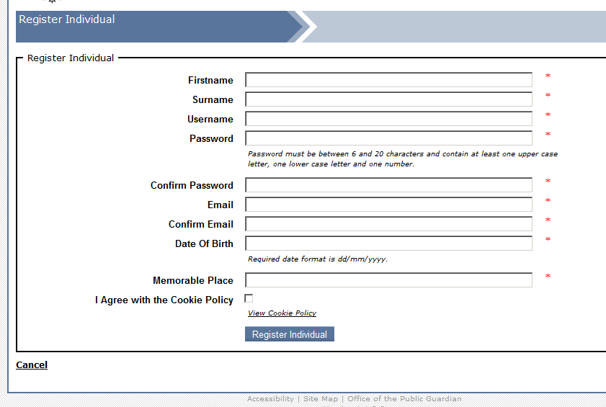
Agree with the cookie policy. This can be viewed by clicking on the link below the checkbox.
3. When the user information has been entered click Register Individual

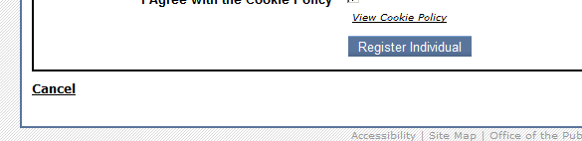.

4. The user can now login to EPOAR.

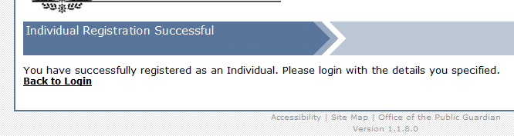

Once logged onto EPOAR an Individual can
- View registrations
- Create registrations
- Amend registrations
- Make payments

