If you forget your Username or Password on EPOAR

1. Request Username Reminder

If you forget your username, you can follow these steps:

Click the Request Username Reminder link on the login page;

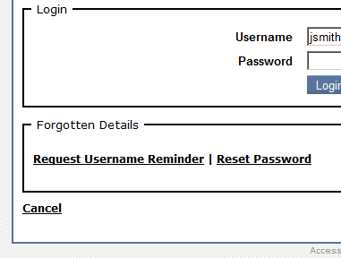

Provide the following details:

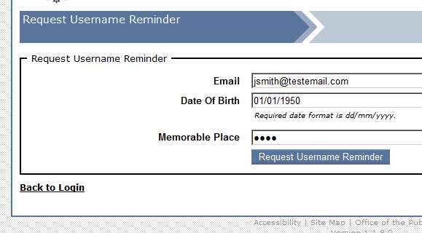

Click Request Username Reminder
An email containing a reminder of the username is then sent to the email address you supplied at registration.

2. Reset Password

If you forget your password, then you can follow these steps:

Click the Reset Password link on the login page;

Provide the following details:

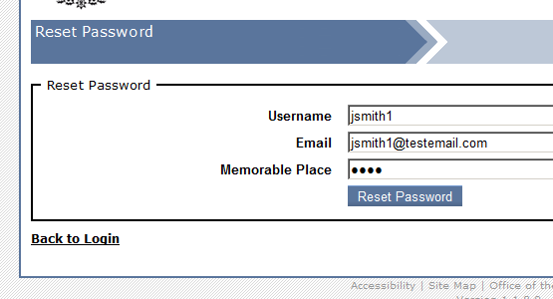

Click Reset Password
An email containing a new password is then sent to the email address supplied at registration.

