Create Registration on EPOAR

This action is only available to users with the Agent Data Entry role.

1. Click Create

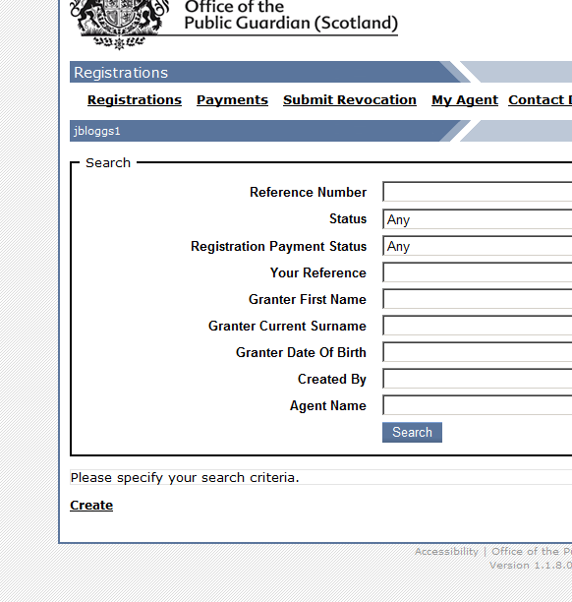

2. Read and agree to the statutory requirements.

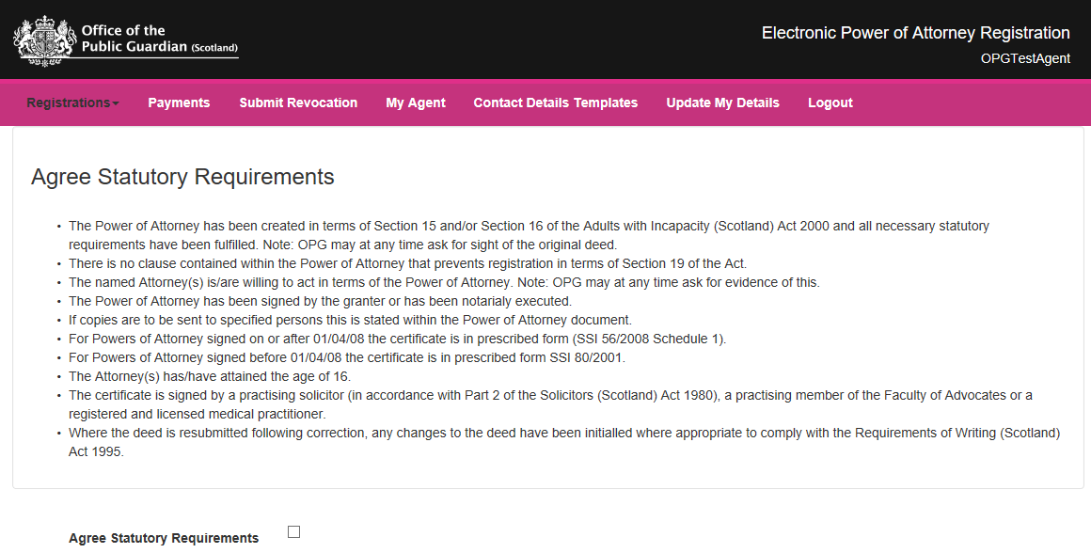

Select the appropriate jurisdiction statement that applies.

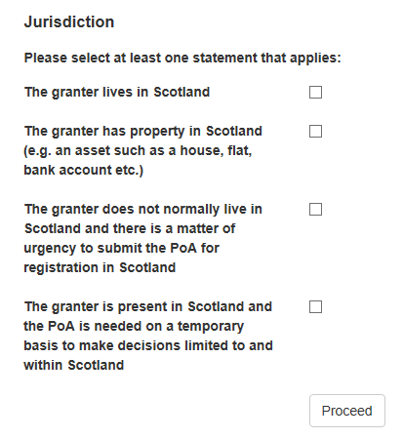
Click Proceed

3. Enter the registration details

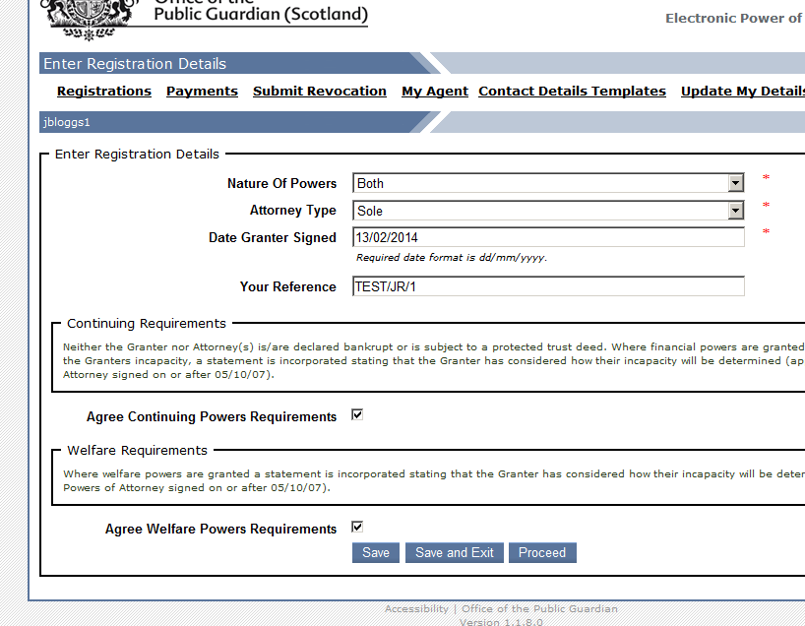

Agree to the powers requirements appropriate for the Nature of Powers selection made.

Click Proceed.

While proceeding through the Registration wizard, it is possible to click the Proceed button to proceed to the next screen, click the Return button to go back to the previous page, click the Save button to save the Registration and continue, or click the Save and Exit button to save your progress and view the Registration. If saved, the Registration can be completed at a later date.

4. Enter Granter’s details

If “Other” is selected for Title, ‘Title If Other’ must be specified

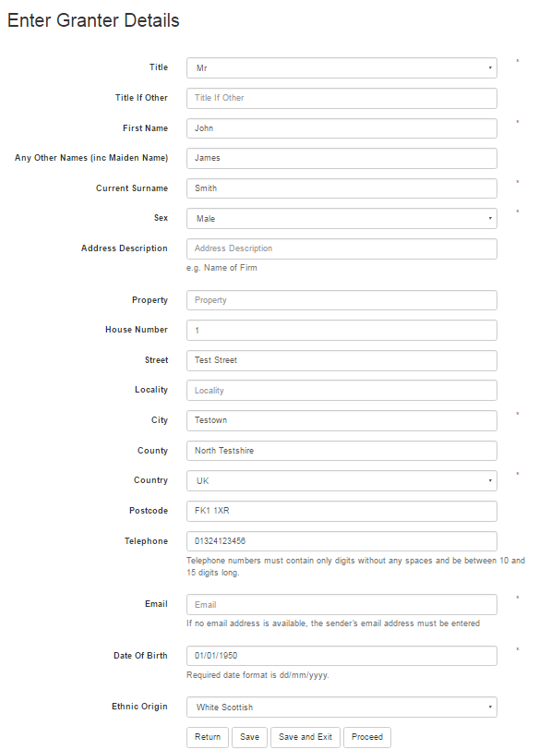
House/building name
An email address must be input

- One of Description, Property and House Number must be entered;
- If House Number is entered, Street is also required;
- If Country is “UK”, Postcode is required;
- The Granter must be 16 years of age or over.

Click Proceed
5 Enter sender’s details

A Contact Details Template may be used to automatically fill in most of the fields. To use a Contact Details Template, click the Select link beside the desired template.

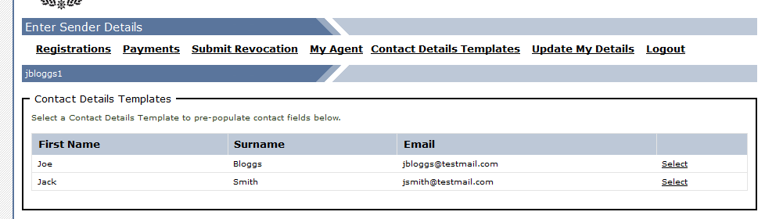

Alternatively, manually input sender details on form.

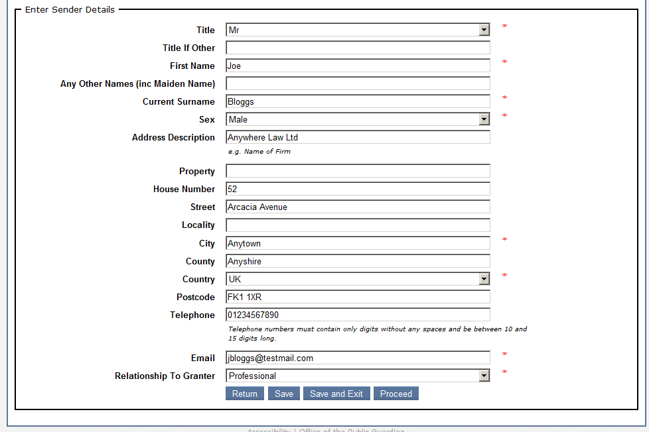

Click Proceed

6. Manage Attorney’s

Click Create Attorney

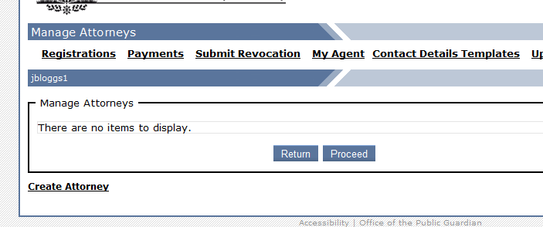

If available, a Contact Details Template may be used to automatically fill in most of the fields. To use a Contact Details Template, click the Select link beside the desired template

Alternatively, manually input attorney details on form.

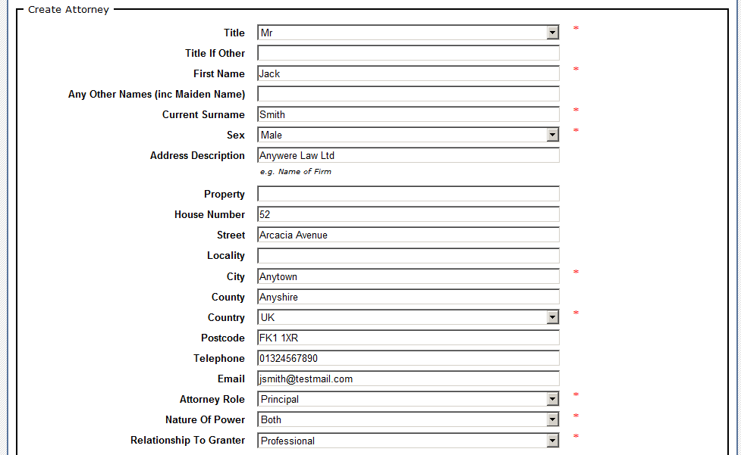
Insert attorney role - Principal (sole/joint) or Substitute.


Checking this box will also create the Attorney as a Specified Person. Please note that there must be an instruction in the Deed for a Specified Person to receive a copy of the Registered Deed. If “Email” is selected for Return Type, an email address must be provided.

If attorney is not a specified person please leave the return type box blank.

Click Create

From this screen you can Update or Delete existing attorney details.

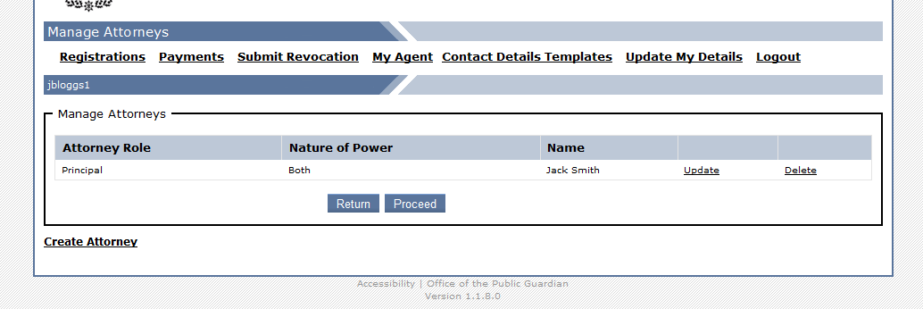

Follow the above step to input additional attorney’s if required.

When all attorney details have been input Click Proceed.

7. Manage Specified People

Under section 19(5)(b) of the Adults with Incapacity (Scotland) Act 2000 (As Amended), the Public Guardian shall where the document conferring the continuing or welfare power of attorney so requires, send a copy of it to not more than two specified individuals or holders of specified offices or positions.

If you have forgotten to tick the specified person box on the attorney page or if the specified person is not an attorney you can input their details by Clicking Create Specified Person.

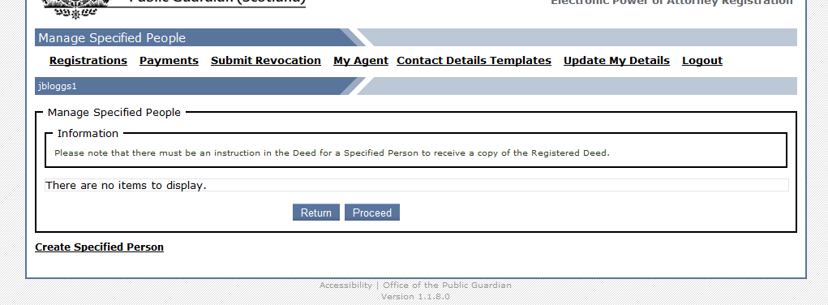

Input specified people details.

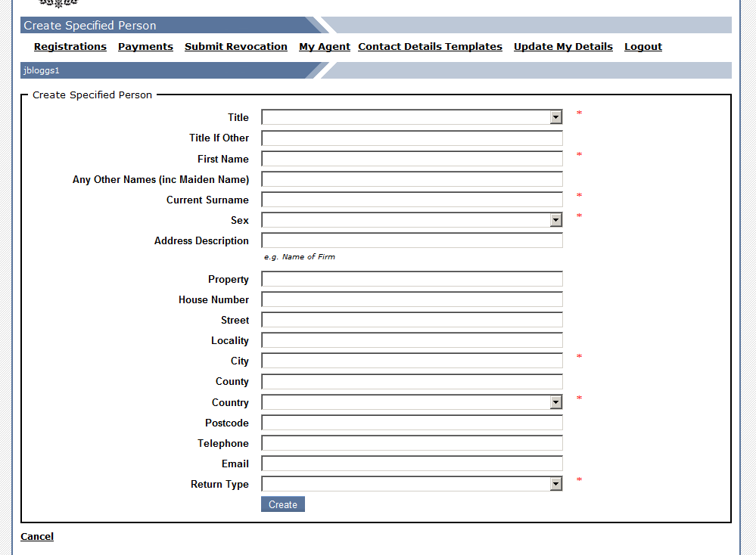
House/building name

If “Email” is selected for Return Type, the specified persons email address must be provided.

Click Create

Follow the above step to input an additional specified person if required.

From this screen you can Update or Delete specified people details.

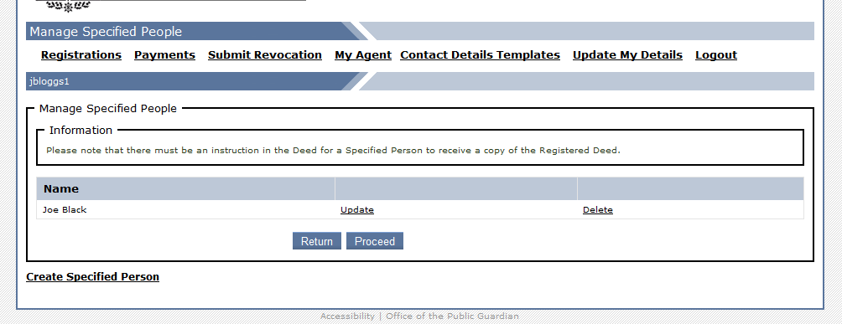

When all specified people details have been input Click Proceed.

8. Upload Deed

The uploaded Deed must be a PDF file and cannot have a file size of more than 2 MB.
(Scanner resolution should be no more than 200dpi (dots per inch) and paper size should be set to A4)

Click Browse and select document from file location.

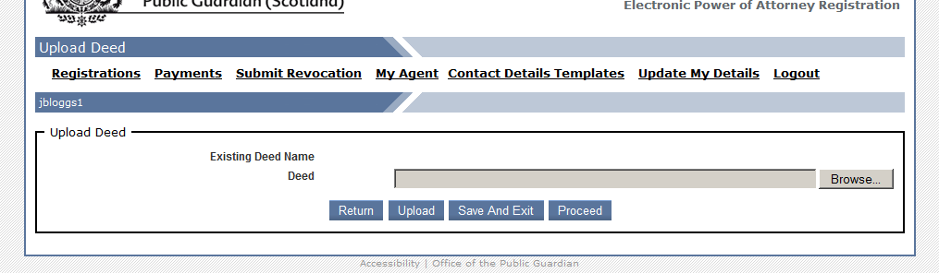

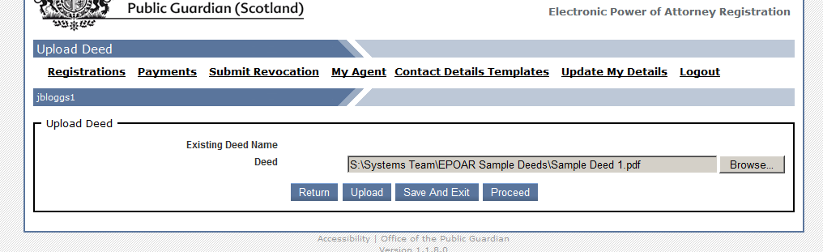

Click Upload

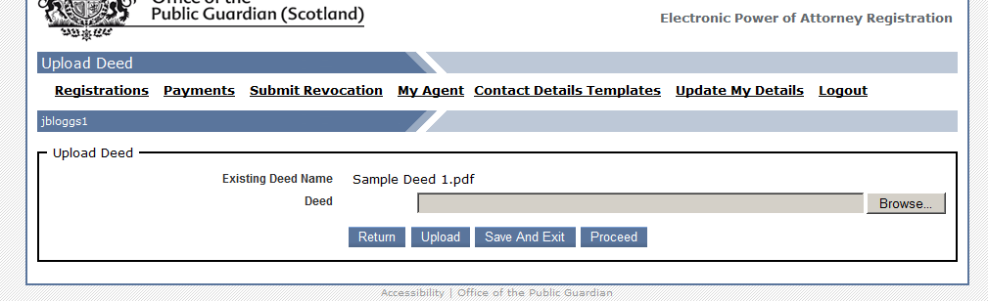

If you realise at this stage that you have uploaded the incorrect document, follow the above steps to upload the correct document. This will overwrite the first document uploaded.

Once the deed has been uploaded click Proceed

You can also view the deed for a registration by performing the following:

1. Click the Registrations link from the main menu;
2. Enter any appropriate search criteria that will help narrow down the search;
3. Click the Search button;
4. Click the View link next to the desired Registration within the search results;
5. Click the View Deed action link to open or save the Deed.

9. Select Payment Option

This Registration cannot be amended further once payment has been taken.

In the case of an Agent having to process many Registrations, it may be easier to pay for them simultaneously.
Click Pay Later. Once a Registration is marked as “Awaiting Payment”, further amendments can still be made by proceeding through the Registration wizard. The Registration will then be marked as “Awaiting Payment” and will be available to select as part of a multiple payment.

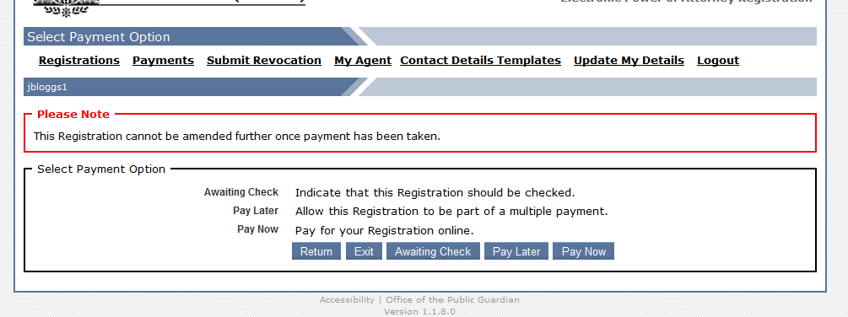

Before a Registration is paid, it may be required to be checked by another user. For example, a Registration may be required to be checked by a solicitor before submission.
Click Awaiting Check. The Registration will now be marked as “Awaiting Check”. To pay for the Registration, proceed through the Registration wizard and at the payment screen chose one of the payment options.

e-Kashu is a secure payment system provided by CreditCall, which is certified under the PCI DSS (Payment Card Industry Data Security Standard). Since the entire transaction is handled by CreditCall, no payment details are stored within EPOAR.

Click Pay after verifying Registration details and amount.

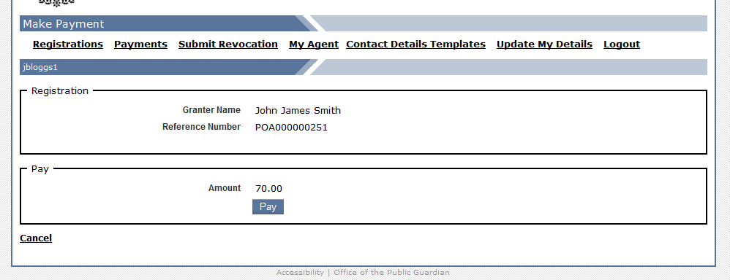

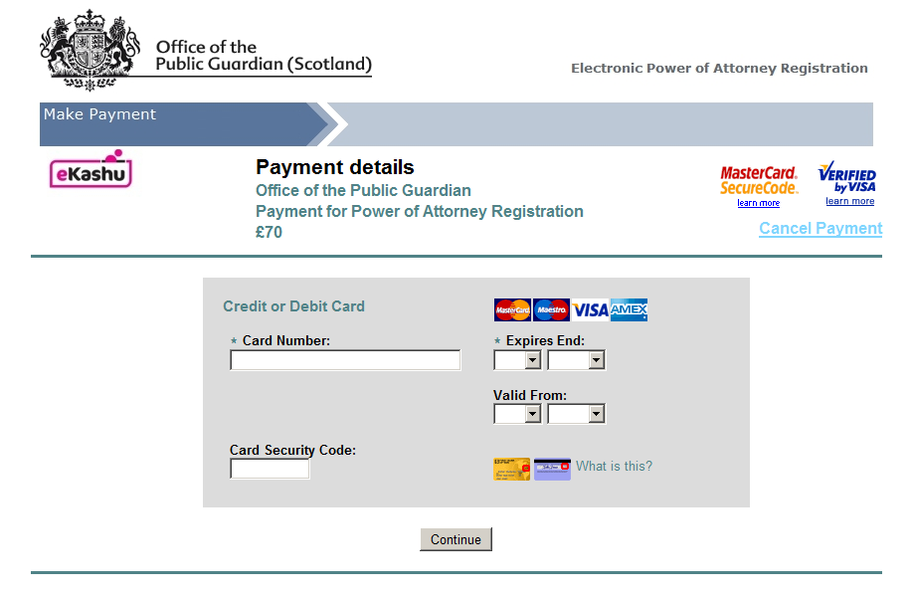
Enter payment details and click Continue.

On completion, the user is returned to EPOAR and a message informs of the success or failure of the payment. If successful, a confirmation email is sent to the Registration User and all non-deleted Administrators for the User’s Agent.

The Registration is now ready to be processed by OPG.

