How to create/delete a user on EPOAR

To create a new user

Log in to EPOAR

1. Click My Agent

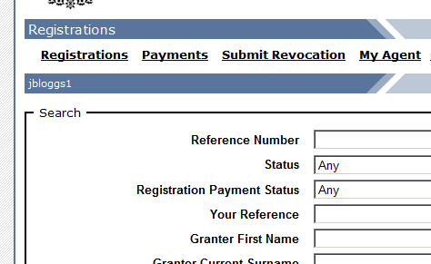

2. Click Create User

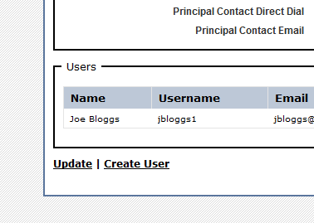
3. Input user details

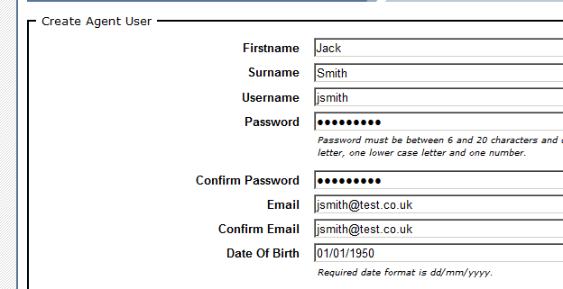

Password must be between 6 and 20 characters and contain at least one lowercase character, one uppercase character and one digit. (Ask user to input password themselves).

NB Block capitals should not be used. Please use title case. Eg Mr Smith.

4. Choose what role(s) the user will have


If the user is to be given both roles use the CTRL key to select/deselct multiple entries

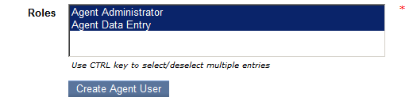

5. Click Create Agent User

The user will receive an automated confirmation email.

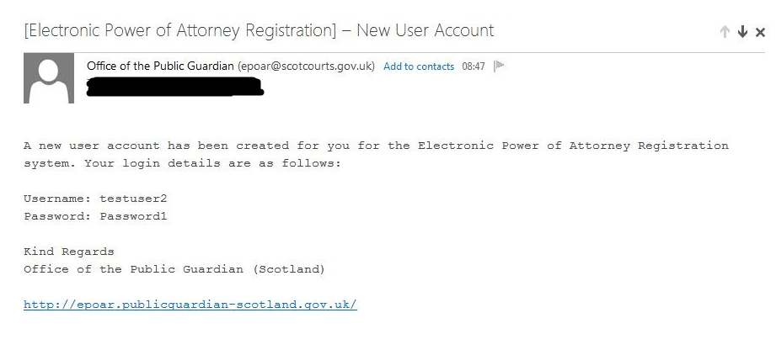

To delete an existing user

Log in to EPOAR

1. Click My Agent

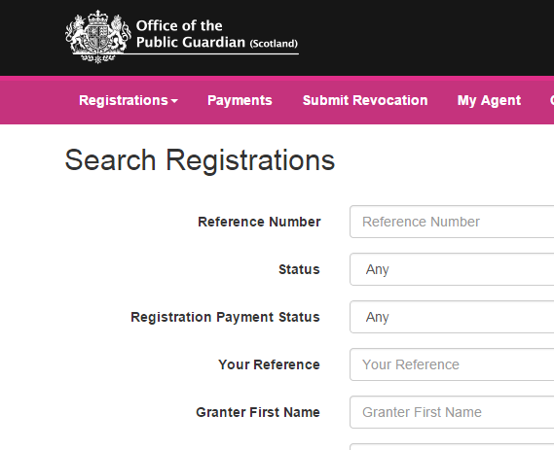

2. At the bottom of the page select the user to be deleted. Click View

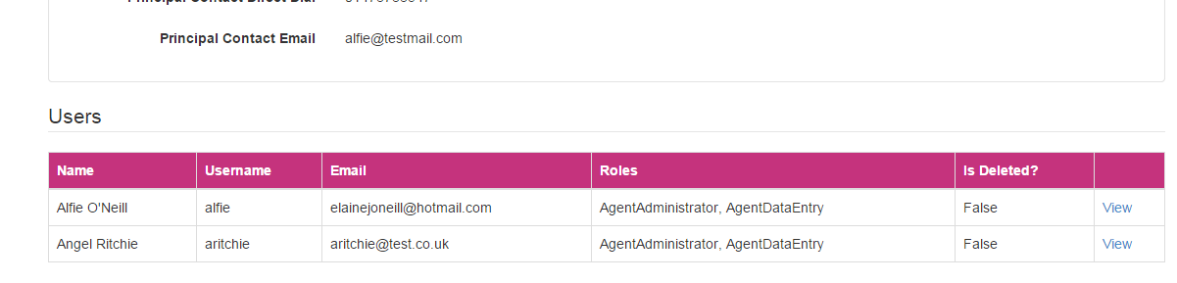

3. Click Delete

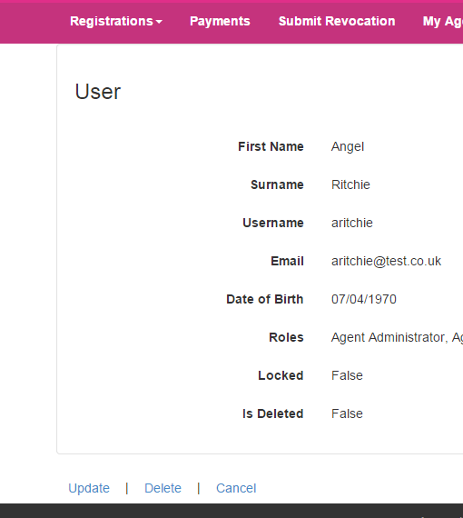

4. Click Delete

