What to do if your Registration is rejected

You will be advised by email if your registration has been rejected and the reasons for rejection. Once you have made the necessary changes you will need to restart the registration process from the beginning, it is not possible to resubmit the original registration.

Any alterations made to the Power of Attorney including the insertion of new pages must be initialed by the Granter. Any changes made to the certificate must be initialed by the person who signed it. It is important to ensure therefore that all alterations are appropriately initialed before resubmitting the Power of Attorney for registration. You will have to confirm this when agreeing the statutory requirements within the EPOAR system.

- If the granters name has been changed in any way e.g., middle name added/removed, maiden name added/removed etc., payment will be required and a request for a refund for the original registration should be sent to EPOAR@scotcourts.gov.uk.

- If the rejection is for any other reason e.g., issues affecting the deed, certificate or attorney details etc., when you reach the payment screen you will have the option to “Pay by Transfer”.

(The granters name must be entered as it was on the original registration in order for the pay by transfer function to work).

Click Pay by Transfer

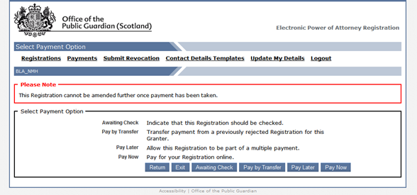

Select the case the payment is to be transferred from

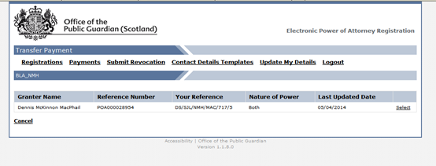

Check details and Click Transfer Payment

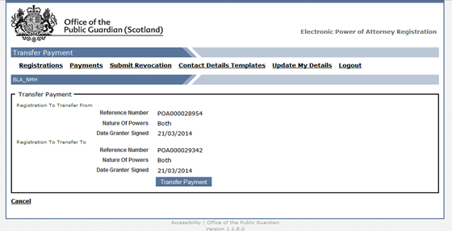

Confirmation of successful transfer.

