Thinking about applying for financial guardianship?
1
What’s a financial guardianship order?
This is an order granted by the Sheriff which gives legal authority to appointed persons, called guardians. The order allows guardians to make specific financial and / or property decisions on behalf of an incapable adult who can’t make these decisions for themself. An adult is someone aged over 16 years but if needed, you can make an application 3 months before a child’s 16th birthday. This means that the order is in place when the child becomes 16.
Financial guardianship might be needed if there is no other authority in place and decisions need to be taken to safeguard / promote the adult’s interests. However, before applying you should think about some of the other options for decision making, such as the access to funds scheme, operated by the Public Guardian, or an intervention order would be a more suitable option.
If you have considered your options and you feel that guardianship is necessary, we strongly recommend that you take legal advice as the application for guardianship is a legal procedure. The application must state the individual powers that you need to help with financial decision making both now and in the foreseeable future. The order usually lasts for 3 years; in some cases, it could be longer. The Sheriff will decide how long the appointment will last.
2
Who can apply to be a financial guardian?
Anyone with an interest in an adult’s affairs can apply to become a guardian. This could be the adult’s spouse, partner, relative or friend. Sometimes it might be helpful to have more than one guardian such as a joint or a substitute guardian. However, the Sheriff will need to be satisfied that anyone wishing to be guardian is a suitable person and they have the ability and skills to carry out the role effectively. As part of the guardianship application process those wishing to be appointed as a financial guardian are asked to complete a form about their circumstances. The form allows applicants to agree to the responsibilities of the role prior to the court making the guardianship order. More information about the administrative duties is outlined on the following page of this leaflet.

You should note that the first year of financial guardianship might be time consuming. It is important that you consider if you have the time and ability to commit to the appointment. Financial guardians hold a position of trust and must act with due skill and care when exercising their powers.
3
Costs associated with financial guardianship

Civil legal aid might be available to help with some of the legal costs of making the application. If you do not have legal aid, then you may be able to recover the costs of applying to court from the adult’s estate. The decision to award expenses is made by the Sheriff and will only be made if your solicitor asks for the authority to recover these costs.

We charge a fee for some of the services we provide. There are certain circumstances where you may be entitled to be exempt from paying our fees. A full list of our fees and details of exemptions and how to apply can be found on our website or by contacting us.
Protecting the adult’s estate against financial loss
4

On granting a financial order the Sheriff may decide to set caution. This is an insurance bond that is designed to protect the adult’s estate against financial loss because of a guardian’s mismanagement. Your solicitor will normally make any arrangements with the caution company on your behalf. Until the bond of caution is accepted by us you will not be able to exercise any of the powers granted by the Sheriff. Further information on caution is available from our website, or we can provide you with a leaflet containing the contact information of the relevant insurance companies. The cost of the bond of caution can be paid from the adult’s estate.
5
Your certificate of appointment
We will issue you with a certificate of appointment when we have received confirmation that the financial guardianship has been granted, and if applicable when caution has been put in place.

N.B. You will only have the power to gather information and investigate the extent of the adult’s estate and pay day-to-day living expenses until we have approved the inventory of estate and management plan.

The certificate of appointment acts as proof of your appointment. It should be printed and kept in a safe. Financial institutions, such as banks, pension providers etc. will ask to see your certificate before you can deal with the adult’s financial affairs.

6
6
6
Your authority
6

The Sheriff will have decided how long your appointment will last. This will be stated in the court order. If your appointment is due to expire you can apply to renew your authority. This is done by making a renewal application to the court. See our website for more information.
7
Supervision by the Public Guardian
The Public Guardian, an official of the Scottish Courts and Tribunals Service, has been given statutory authority to supervise financial guardians.
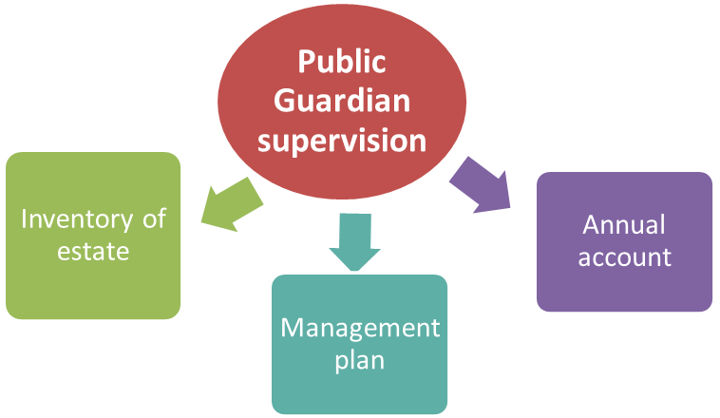

Duties of the financial guardian
8
Once appointed we will contact you by telephone to discuss your responsibilities as financial guardian. This usually happens 2 weeks after we send your certificate of appointment to you. It is likely that you will need to send us an inventory of the adult’s estate, management plan and annual account. We will explain more about what you need to do when we contact you by telephone.
Throughout your appointment we will write to you to let you know what we need you to do. We charge fees for carrying out some of our work. If a fee is required, we will provide information to you about how much this will be.
If we are unable to fulfil our supervision role because a financial guardian is not able to meet the necessary requirements or provide us with information when requested, we will go back to the court to ask the Sheriff to get involved. This could mean ordering a financial guardian to provide documentation to us or removing a financial guardian from their appointment.
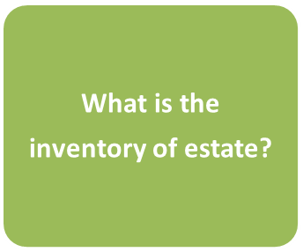
So, what’s involved?
What is an annual account? The inventory of estate lets you tell us about all the income, assets, expenditure and debts belonging to the adult. We provide guidance and a form for you to use. A short video is available and explains how to complete the form. You will need to contact various fund holders e.g. banks, building societies, Department of Work and Pensions. You will need to send supporting information along with the inventory, such as:
bank / building society statements or a letter from them confirming the balance of any accounts held by the adult
letters or statements from benefit or pension providers
evidence of the values of any stocks / shares and or investments
evidence of any debts that existed at date of appointment

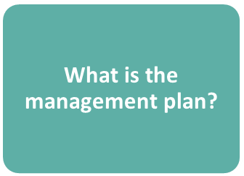
Most financial guardians are asked to complete a management plan. This lets you tell us how you intend to manage the adult’s estate for their benefit. We are looking for specific information about the adult’s day to day outgoings e.g. utilities, mortgage, rent, care costs, hobbies and holidays.
We provide you with guidance and a form so you can tell us about what you propose to do longer-term about the adult’s property and / or finances. A short video is available and explains how to complete the form. You will need to take financial advice as how best to manage the adult’s property and finances if there is more than £100,000 of moveable assets e.g. bank / building society accounts. We provide worked examples to help you understand what type of information you need to tell us.


What is an annual account? You will be expected to send us a yearly record of your financial transactions with the adult's estate. We provide a form to allow you to do this. A short video is available from the website which explains how to complete the form. When you send the form to us you will need to supporting information, such as:
bank statements covering the full period
all contract notes for the sale or purchase of stocks and shares
receipts / invoices for purchases of individual items over the value of £200
award letters from the Department of Work & Pensions / Social Security Scotland
evidence that you have renewed the bond of caution

9
Selling or buying property on behalf of an adult

If the adult has accommodation, known as their ‘dwelling house’, and you are granted powers to sell this property, you might need to get our consent before the property is sold. You may also need to get our consent to the sale price. A similar process exists if you have been granted powers to buy a property for the adult. Forms are available from our website along with additional information on the processes.

10
Contact us
Tel: 01324 678300
Email: opgorders@scotcourts.gov.uk
Website: www.publicguardian-scotland.gov.uk
X (formerly known as Twitter): @OPGScotland
Further information
You might find the information on our website a useful place to start. While we are happy to help with general enquiries, we are unable to provide legal advice.
The Scottish Government provides an excellent publication ‘Guardianship and Intervention orders – making an application a Guide for Carers’ and a Code of Practice for guardians. These are available for download alternatively hard copies may be available on request by emailing: awireform.queries@gov.scot
Office of the Public Guardian (Scotland), Hadrian House, Callendar Business Park, Callendar Road, Falkirk FK1 1XR

